HTML Semantic Elements

📘 Definition
# Source: AI Source: Provided by: [Data Path: Persons Table -> ID Column: 1, Name_En Column: Motasem Essam] -> From: [ChatGPT] on [5/6/2026]
HTML semantic elements are elements that clearly describe their meaning and purpose to:
- browsers
- developers
- search engines
- screen readers
👉 Semantic = “meaningful”

🧠 Why Semantic Elements are Important
# Source: AI Source: Provided by: [Data Path: Persons Table -> ID Column: 1, Name_En Column: Motasem Essam] -> From: [ChatGPT] on [5/6/2026]
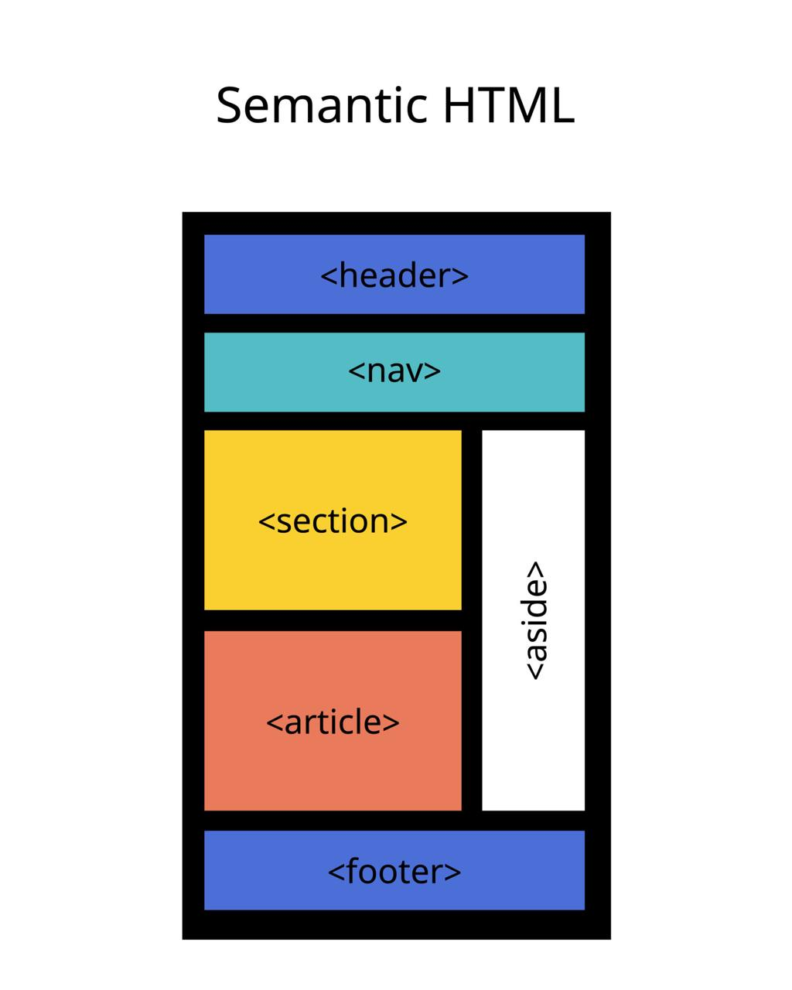
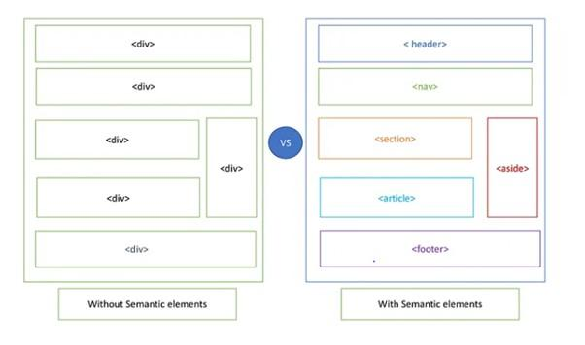
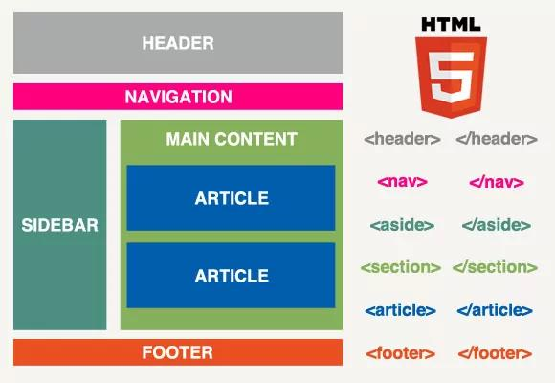
Semantic elements give meaning and structure to webpage content.
Instead of using generic elements like <div>, semantic elements clearly describe their purpose.
✔ Better webpage structure
✔ Improved SEO
✔ Easier to read and maintain
✔ Better accessibility
✔ Better Compatibility
✔ Cleaner Code

🔤 Common HTML Semantic Elements

1. <header>
# Source: AI Source: Provided by: [Data Path: Persons Table -> ID Column: 1, Name_En Column: Motasem Essam] -> From: [ChatGPT] on [5/6/2026]
📖 Description
Represents the top section of a webpage or section.
💻 Example:
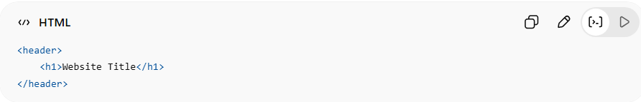
<header>
<h1>Website Title</h1>
</header>

2. <nav>
# Source: AI Source: Provided by: [Data Path: Persons Table -> ID Column: 1, Name_En Column: Motasem Essam] -> From: [ChatGPT] on [5/6/2026]
📖 Description
Contains navigation links.
💻 Example:
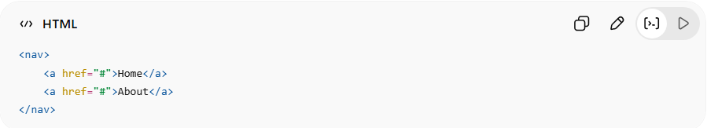
<nav>
<a href="#">Home</a>
<a href="#">About</a>
</nav>

3. <main>
# Source: AI Source: Provided by: [Data Path: Persons Table -> ID Column: 1, Name_En Column: Motasem Essam] -> From: [ChatGPT] on [5/6/2026]
📖 Description
Represents the main content of the webpage.
💻 Example:
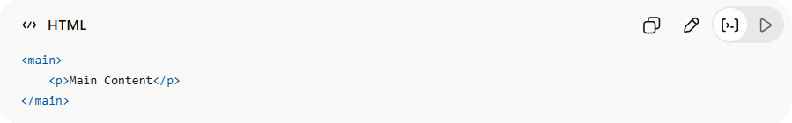
<main>
<p>Main Content</p>
</main>

4. <section>
# Source: AI Source: Provided by: [Data Path: Persons Table -> ID Column: 1, Name_En Column: Motasem Essam] -> From: [ChatGPT] on [5/6/2026]
📖 Description
Defines a content section.
💻 Example:
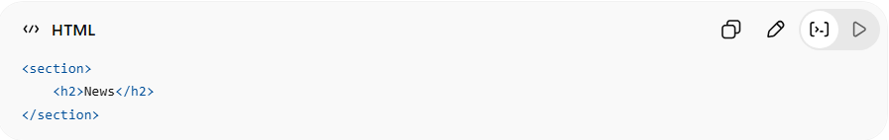
<section>
<h2>News</h2>
</section>

5. <article>
# Source: AI Source: Provided by: [Data Path: Persons Table -> ID Column: 1, Name_En Column: Motasem Essam] -> From: [ChatGPT] on [5/6/2026]
📖 Description
Represents independent content:
- blog post
- article
- news story
💻 Example:
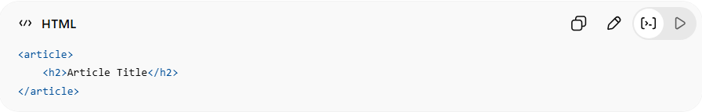
<article>
<h2>Article Title</h2>
</article>

6. <aside>
# Source: AI Source: Provided by: [Data Path: Persons Table -> ID Column: 1, Name_En Column: Motasem Essam] -> From: [ChatGPT] on [5/6/2026]
📖 Description
Represents side content related to the main content.
💻 Example:
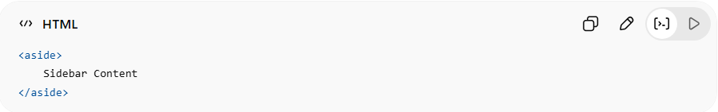
<aside>
Sidebar Content
</aside>

7. <footer>
# Source: AI Source: Provided by: [Data Path: Persons Table -> ID Column: 1, Name_En Column: Motasem Essam] -> From: [ChatGPT] on [5/6/2026]
📖 Description
Represents the bottom section of a webpage or section.
💻 Example:
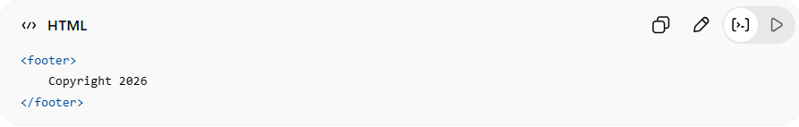
<footer>
Copyright 2026
</footer>

8. <figure> and <figcaption>
# Source: AI Source: Provided by: [Data Path: Persons Table -> ID Column: 1, Name_En Column: Motasem Essam] -> From: [ChatGPT] on [5/6/2026]
📖 Description
Used for images/media with captions.
💻 Example:
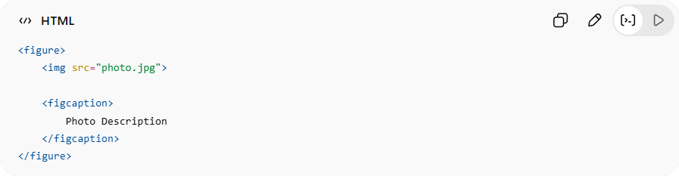
<figure>
<img src="photo.jpg">
<figcaption>
Photo Description
</figcaption>
</figure>

9. <details>
# Source: AI Source: Provided by: [Data Path: Persons Table -> ID Column: 1, Name_En Column: Motasem Essam] -> From: [ChatGPT] on [5/6/2026]
📖 Description
Creates a collapsible section that users can open and close.
💻 Example:
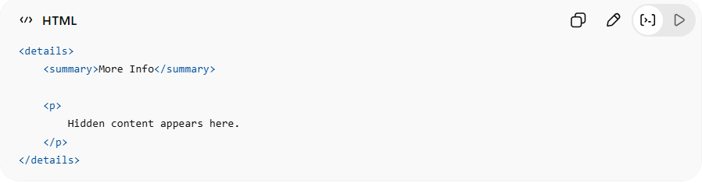
<details>
<summary>More Info</summary>
<p>
Hidden content appears here.
</p>
</details>
👉 Click to expand/collapse content

10. <summary>
# Source: AI Source: Provided by: [Data Path: Persons Table -> ID Column: 1, Name_En Column: Motasem Essam] -> From: [ChatGPT] on [5/6/2026]
📖 Description
Defines the visible title for a <details> element.
💻 Example:
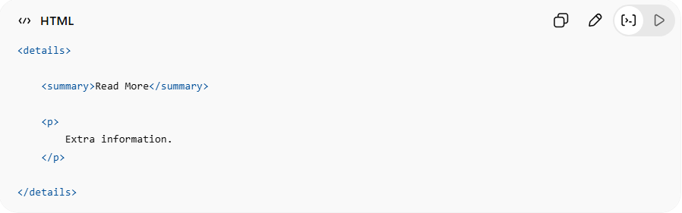
<details>
<summary>Read More</summary>
<p>
Extra information.
</p>
</details>
👉 Acts like a clickable heading

11. <mark>
# Source: AI Source: Provided by: [Data Path: Persons Table -> ID Column: 1, Name_En Column: Motasem Essam] -> From: [ChatGPT] on [5/6/2026]
📖 Description
Highlights important text.
💻 Example:
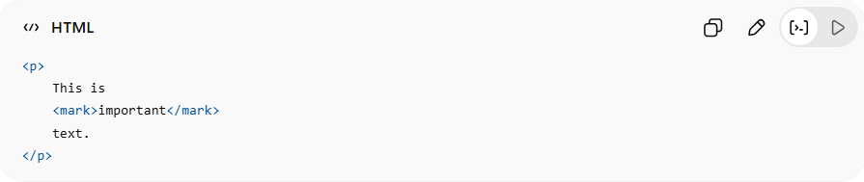
<p>
This is
<mark>important</mark>
text.
</p>
👉 Browser highlights text with yellow background

12. <time>
# Source: AI Source: Provided by: [Data Path: Persons Table -> ID Column: 1, Name_En Column: Motasem Essam] -> From: [ChatGPT] on [5/6/2026]
📖 Description
Represents a date or time.
💻 Example:
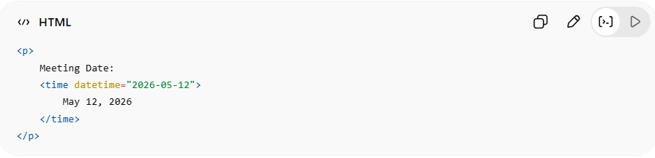
<p>
Meeting Date:
<time datetime="2026-05-12">
May 12, 2026
</time>
</p>
👉 Helps browsers and search engines understand dates/times

Example

Full Example
# Source: AI Source: Provided by: [Data Path: Persons Table -> ID Column: 1, Name_En Column: Motasem Essam] -> From: [ChatGPT] on [5/6/2026]
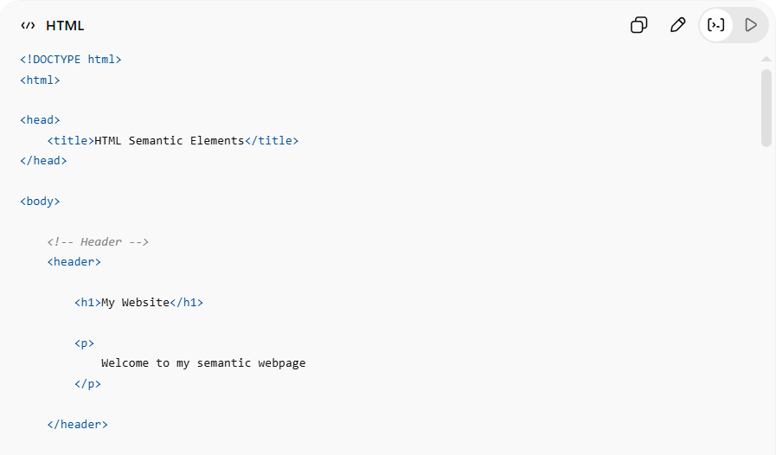
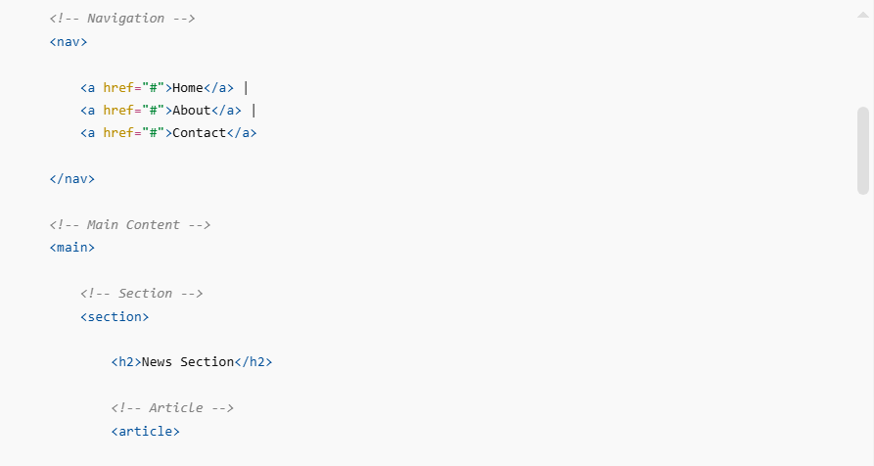
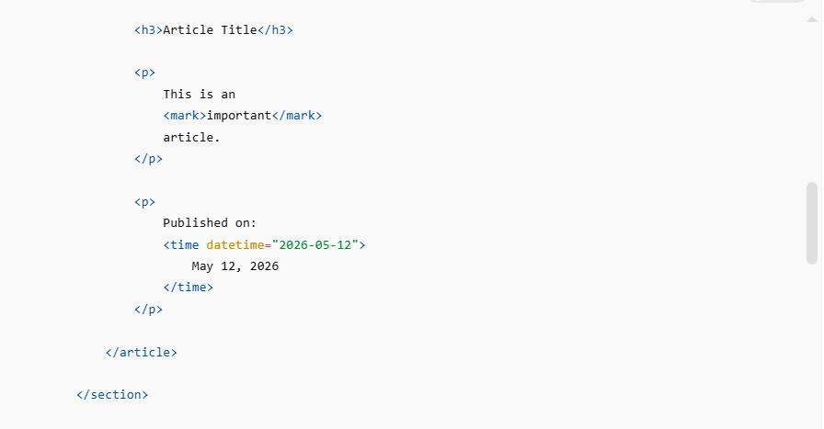
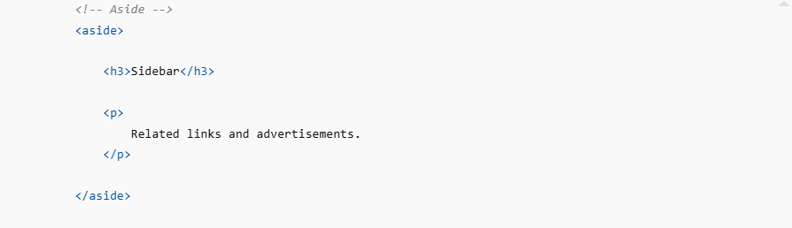
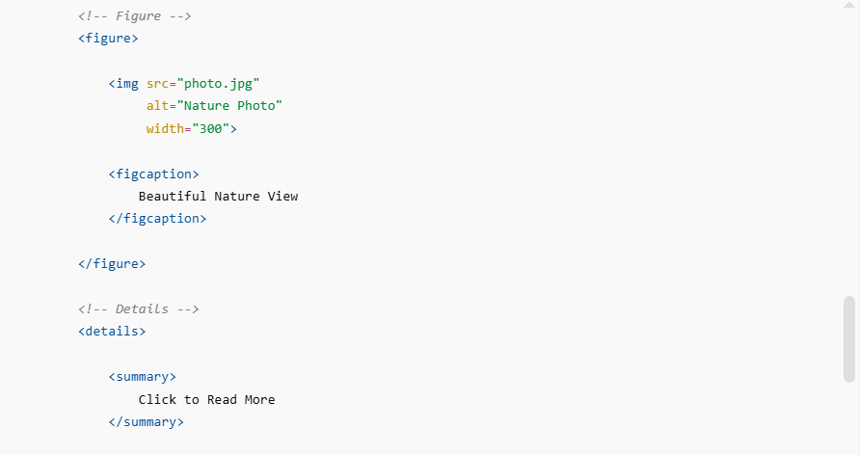
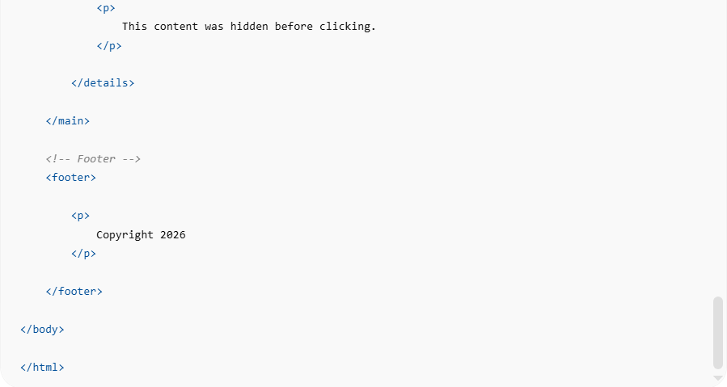
<!DOCTYPE html>
<html>

<head>
<title>HTML Semantic Elements</title>
</head>

<body>

<!-- Header -->
<header>

<h1>My Website</h1>

<p>
Welcome to my semantic webpage
</p>

</header>

<!-- Navigation -->
<nav>

<a href="#">Home</a> |
<a href="#">About</a> |
<a href="#">Contact</a>

</nav>

<!-- Main Content -->
<main>

<!-- Section -->
<section>

<h2>News Section</h2>

<!-- Article -->
<article>

<h3>Article Title</h3>

<p>
This is an
<mark>important</mark>
article.
</p>

<p>
Published on:
<time datetime="2026-05-12">
May 12, 2026
</time>
</p>

</article>

</section>

<!-- Aside -->
<aside>

<h3>Sidebar</h3>

<p>
Related links and advertisements.
</p>

</aside>

<!-- Figure -->
<figure>

<img src="photo.jpg"
alt="Nature Photo"
width="300">

<figcaption>
Beautiful Nature View
</figcaption>

</figure>

<!-- Details -->
<details>

<summary>
Click to Read More
</summary>

<p>
This content was hidden before clicking.
</p>

</details>

</main>

<!-- Footer -->
<footer>

<p>
Copyright 2026
</p>

</footer>

</body>

</html>

Real Example
# Source: ScreenShot Source: Provided by: [Persons Table -> ID Column: 1, Name_En Column: Motasem Essam] -> Tool: [Automation Table -> ID Column: 16, Name_En Column: Screen Capture] -> From [Operating System: Windows] on [5/6/2026]
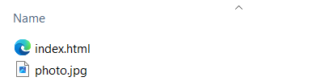
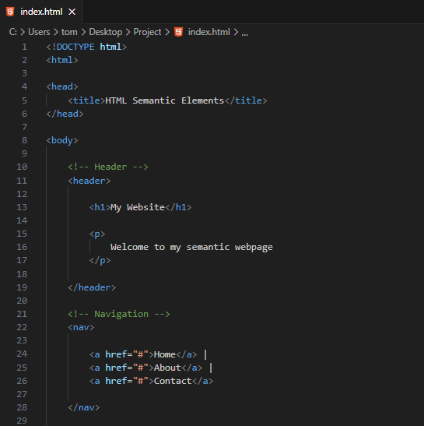
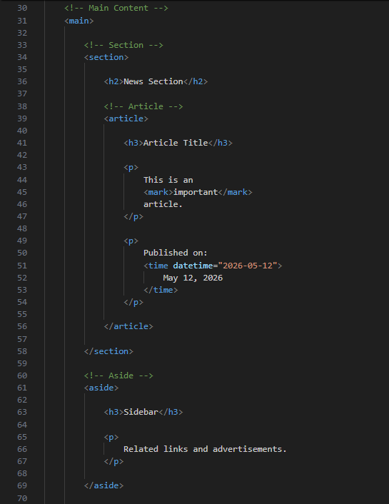
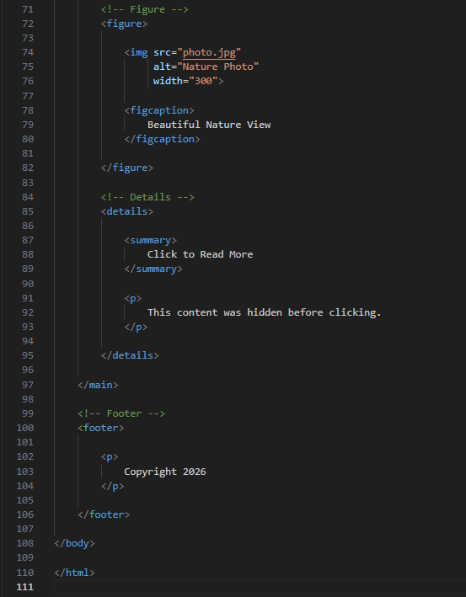

<!DOCTYPE html>
<html>

<head>
<title>HTML Semantic Elements</title>
</head>

<body>

<!-- Header -->
<header>

<h1>My Website</h1>

<p>
Welcome to my semantic webpage
</p>

</header>

<!-- Navigation -->
<nav>

<a href="#">Home</a> |
<a href="#">About</a> |
<a href="#">Contact</a>

</nav>

<!-- Main Content -->
<main>

<!-- Section -->
<section>

<h2>News Section</h2>

<!-- Article -->
<article>

<h3>Article Title</h3>

<p>
This is an
<mark>important</mark>
article.
</p>

<p>
Published on:
<time datetime="2026-05-12">
May 12, 2026
</time>
</p>

</article>

</section>

<!-- Aside -->
<aside>

<h3>Sidebar</h3>

<p>
Related links and advertisements.
</p>

</aside>

<!-- Figure -->
<figure>

<img src="photo.jpg"
alt="Nature Photo"
width="300">

<figcaption>
Beautiful Nature View
</figcaption>

</figure>

<!-- Details -->
<details>

<summary>
Click to Read More
</summary>

<p>
This content was hidden before clicking.
</p>

</details>

</main>

<!-- Footer -->
<footer>

<p>
Copyright 2026
</p>

</footer>

</body>

</html>
# Source: GIF Source: Provided by: [Persons Table -> ID Column: 1, Name_En Column: Motasem Essam] -> Tool: [Automation Table -> ID Column: 17, Name_En Column: GIF Recorder] -> From [Operating System: Windows] on [5/6/2026]


⚖️ Semantic vs Non-Semantic
# Source: AI Source: Provided by: [Data Path: Persons Table -> ID Column: 1, Name_En Column: Motasem Essam] -> From: [ChatGPT] on [5/6/2026]
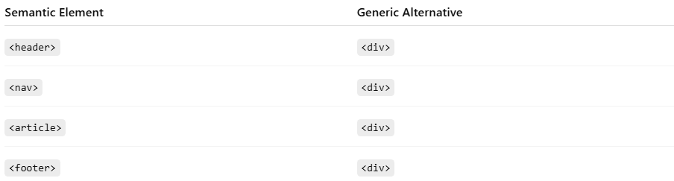
Semantic Element | Generic Alternative
<header> | <div>
<nav> | <div>
<article> | <div>
<footer> | <div>

🚀 In short:
# Source: AI Source: Provided by: [Data Path: Persons Table -> ID Column: 1, Name_En Column: Motasem Essam] -> From: [ChatGPT] on [5/6/2026]
HTML semantic elements clearly describe the structure and purpose of webpage content.

